**Supreme International**

Supreme International manufactures vertical feed processors with a highly developed product line. They became the first company in North America to design, test and manufacture the Vertical Feed Processor. Supreme has revolutionized the livestock feeding industry by adding many new innovative features to the vertical processor that enabled livestock producers to feed their cattle more efficiently allowing them to lower their feed costs and improve their gains.

With its primary manufacturing facility in the City of Wetaskiwin and its secondary facility in the United States, Supreme International operates globally with well established distribution in the Middle East, Japan, Australia, New Zealand, Germany, United Kingdom, Puerto Rico, Dominican Republic, Russia, Mexico, Indonesia, Costa Rica, Hungary and all across the USA and Canada. Supreme has become the benchmark for quality throughout the world. In its continued growth and innovation, Supreme International also expanded into the environmental industry. They build an industrial line of Enviro Processors for the recycling industry to process and blend different waste commodities. To learn more about Supreme International……..

|  |  |
| --- | --- |
| Supreme International | |
| Started in Region | 1953 |
| Business Type | Manufacturer: feed processors and environmental processors |
| Operations | 250,000 sq. ft. facility |
| Employees | 120 |

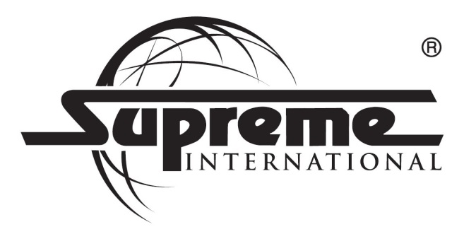

**Home Hardware Western Distribution Center**

Home Hardware Stores Limited is Canada's largest independent home improvement retailer. The company is owned by close to 1,100 independent small business operators from every corner of Canada, who operate under one of four banners: Home Hardware, Home Hardware Building Centre, Home Building Centre and Home Furniture. The company remains a genuinely 100% Canadian, Dealer-owned and operated major retailer.

Home Hardware meets the challenge of servicing its stores with a highly efficient, world-class distribution system. The Home Hardware Western Distribution Center in the City of Wetaskiwin services its Western Canada dealers from Vancouver Island to the Northwest Territories to Manitoba and warehouses over 50,000 products. To learn more about Home Hardware……

|  |  |
| --- | --- |
| Home Hardware Western Distribution Center | |
| Started in Region | 1985 |
| Business Type | National Distribution Center: distribution for national retail chain |
| Operations | 750,000 sq. ft. facility |
| Employees | 450 |

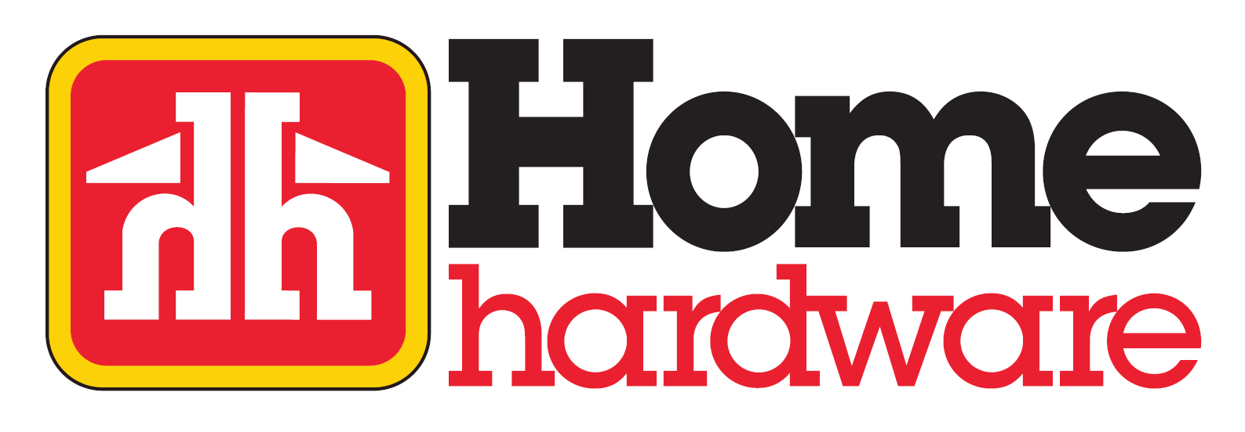

**Manluk Industries**

Manluk specializes in full turnkey manufacturing solutions providing world class quality, delivery and efficiency. While utilizing cutting edge technologies such as robotic integrated manufacturing processes it maintains the old world pride and dedication to exceeding customer satisfaction. These values support industries such as on and off shore drilling, wellhead, downhole tools and mining. The capabilities include forging, heat treating, machining, cladding, wear resistant overlays, corrosion resistant overlays, nickel plating, nitriding, moly coating, HVOF, Xylan. With global span Manluk ships product to over 20 countries throughout North and South America, Europe, Asia, Australia, Middle East, and into Africa. To learn more about Manluk Industries……

|  |  |
| --- | --- |
| Manluk Industries | |
| Started in Region | 1978 |
| Business Type | Manufacturer:  Metal fabrication, machining and forging |
| Operations | 225,000 sq. ft. across 4 Plants |
| Employees | 190 |

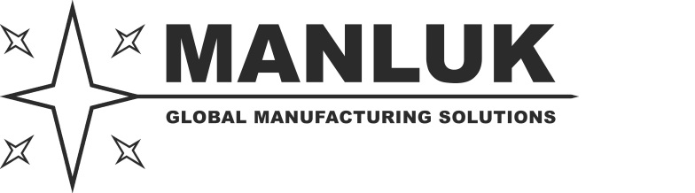

**Wetaskiwin Co-op**

Wetaskiwin Co-op started as a modest supply Co-op that operated out of a box car on a railroad spur in Wetaskiwin in 1917. Today the Co-op operates a lumber, hardware and agro business out of its home and agro center, a state of the art Cardlock facility, a bulk petroleum department, a feed manufacturing facility that produces normal and organic feed and services various locations in North America, and a fertilizer manufacturing and distribution facility. The Wetaskiwin Co-op is one of the largest and unique stores in Alberta servicing the local and North American agriculture market through a large distribution network. To learn more about Wetaskiwin Coop…..

|  |  |
| --- | --- |
| Wetaskiwin Co-op | |
| Started in Region | 1917 |
| Business Type | Retail, hardware and gas: services community and regional farmers  Feed and fertilizer manufacturer: normal and organic animal feed, normal and organic fertilizer |
| Operations | 100,000 sq. ft. across 4 facilities |
| Employees | 250 |

